eDAM Folder Structure:

<https://edam.dev.capitalgroup.com/assets.html/content/dam>

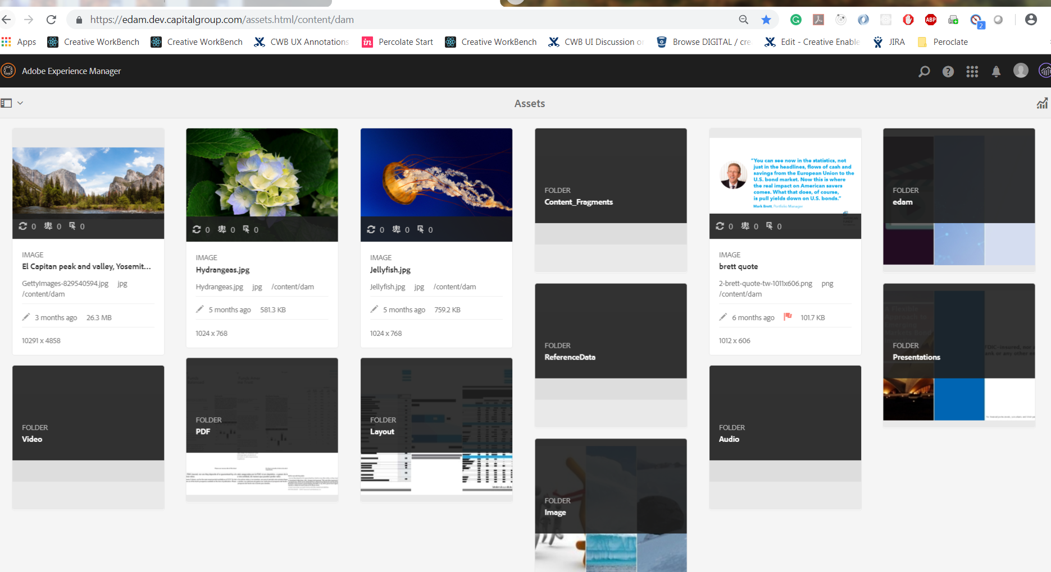

Folder Structure for the eDAM:

1. **Images: GettyImages**
2. **Layout: Includes the Design Files**
3. **PDF: Includes the Published files**
4. **Presentations- Includes PowerPoint files**
5. **Reference Data: Junk data, need to remove it**
6. **Audio: Includes audio .wav format**
7. **Video: Includes media in .mp4 format**
8. **Content Fragments: JSON Format data is available.**

AEM Limit is 1000-1500 files

If the folder is big then search is slowing down then each file is limited to 1000 files🡪001 after that 002 batch process.

Designer will create and Add all the social media, web, print.

A repository is maintained for each of the Image, and thereby it searches by filename and metadata.

Each Image has **work front Task ID**

Each of them is referenced by only adobe tools.

The Asset type is the File Type

URL: <https://edam.dev.capitalgroup.com/mnt/overlay/dam/gui/content/assets/metadataeditor.external.html?_charset_=utf-8&item=/content/dam/referencedata/001/AFIS%20FFS%20Q3%202015%20Class%201%20Archive%20Notice%20Grid.xlsx>

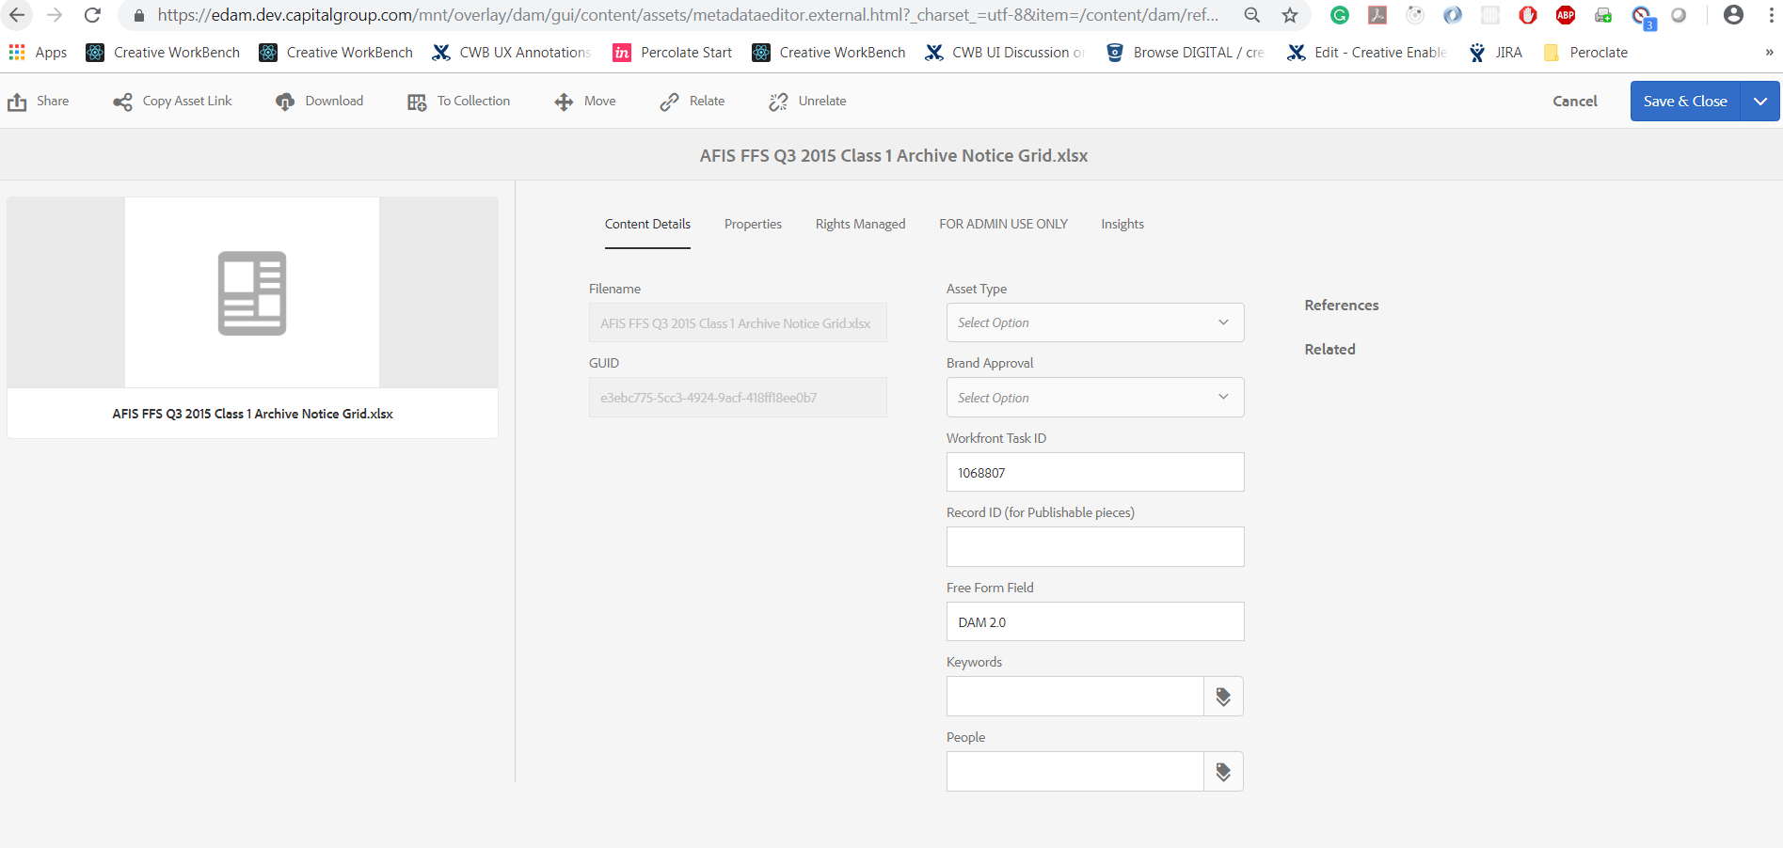

With the help of Reference link we can update the image.

Each Article has transcripts, Videos and Images

The Audio and Video upload size is maximum 2 GB.

eDAM can search inside the documents. Every quarter has 500-600 updates

Key features🡪 Share, Copy, Download, and Edit.  
Graphic Designers involved are Gary Trethaway and Reilly Cheung (REWC)

Pros for the Assets are Create Asset, Search Assets, Download Assets, and Upload Assets.

eDAM files can be used in the Discover.(pdf, images)

Link for AEM Content Fragments: <https://www.youtube.com/watch?v=bj7yragTtNI>

AEM🡪AWS is hosted and data is stored in the Java JVM.

JCR Java Content Repository – All the AEM application data is stored.

Server- Apache Tomcat

Java Version 1.8

Adobe version 63.2, 63.4(new)